SOLENT UNIVERSITY
School of Science and Engineering

MSc Computer Engineering

Academic Year 2024-2025

Thomas Andrews S/N 102592142

Personal Learning Record

Assignment 1

Computer Fundamentals - COM709

Tutor: Dr Kalin Penev [12/12/24]

Contents
Introduction 6
Computer functions, structure and architecture 7
Computer Components 7
Computer performance measurement system 8
Quantum Computing 9
Computer arithmetic, number systems and algorithms 10
Decimal systems 10
Binary systems 10
Hexadecimal systems 10
Computer arithmetic representation 12
Floating points 13
Computer processors, performance, energy efficiency and cooling 14
Memory types 16
Processor performance 17
Max Memory Size and what determines Max Memory Size 18
Processor cooling 20
Storage 22
Hard Disk Drives (HDD) 22
Solid State Drives (SSD) 22
NAS – models, applications and evaluation 25
Raid Models 26
NAS and Cloud storage usage scope and purpose 27
Nas comparison 28
Advanced Concepts and Algorithms 29
Advanced algorithms 30
swarm algorithms 31
Evolutionary algorithms 32
Heuristic algorithms 33
Adaptive algorithms 34
Conclusion 35
References 36
Appendix: 43
Appendix 1 storage comparison. 43
Appendix 2 Merge sort python code: 43
Appendix 3 Shell sort: 46
Appendix 4 Bubble sort: 47

Table 1 Floating point operations per second table 7
Table 3 Classical computing vs Quantum computing 8
Table 5 Hexadecimals 10
Table 7 Hexadecimal, decimal and binary representation including workings. 11
Table 8 Byte breakdown 12
Table 10 Bits breakdown 12
Table 12 Floating points 13
Table 14 Computer processor terminologies 14
Table 16 Memory types 16
Table 18 CPU lithography 17
Table 20 Intel CPU comparison 18
Table 22 AMD CPU comparison 18
Table 24 Apple bionic chip 19
Table 26 Apple bionic chip strengths and weaknesses 19
Table 28 Air cooling vs Liquid cooling 21
Table 30 Noctua vs ICUE table 21
Table 32 SSD vs HDD 23
Table 33 Storage device comparison 24
Table 34 Storage recommendation table 24
Table 35 NAS characteristics 25
Table 36 Raid models 26
Table 37 NAS vs Cloud computing table 27
Table 38 Nas comparison 28
Table 39 Advanced algorithm 30
Table 40 swarm algorithms 31
Table 41 Evolutionary algorithms 32
Table 42 Heuristic algorithms 33
Table 43 Adaptive algorithms 34

Figure 1 Computer architecture 6
Figure 1 Computer architecture 6
Figure 2 Computer data flow diagram 6
Figure 3 CPU components diagram 6
Figure 4 Air cooling diagram 18
Figure 5 Liquid cooling diagram 18
Figure 6 HDD and SSD diagram 20

Introduction
Computers are an incredibly important part of the world. They have implications on most aspects of life, whether it's societal, academic or professional. As a result of this it only seems natural to exploit the fundamentals to provide a detailed research review to which the fundamentals can be learnt and understood.
The review is broken down into six sections each exposing different areas of computer fundamentals. The sections are as shown below:
1 Computer structure functioning and architecture
2 Computer arithmetic, number systems, algorithms
3 Computer processors, performance, energy efficiency and cooling
4 Storage principles, types, and evaluation
5 NAS – models, applications, and evaluation
6 Advanced concepts and algorithms
Within each section the topics have been explored, and information has been derived to which an understanding can be established. The topics have been backed up with relevant sources and research has been conducted using different materials to get a detailed and well-rounded study for each. The research has been further supported with relevant diagrams for the study to provide a greater depth of information and understanding.
Finally, a conclusion has been provided at the end of the project to which an overview has been provided, this has rounded off the study and has provided a final outlook in regard to the fundamentals of computers.

Computer functions, structure and architecture
When discussing the architecture of computers an important concept to understand is the difference between both structure and function. Together they form the subsequent construction of basic computer architecture (William Stalling, 2024).
· Function- The operation of each component and how it performs within the structure
· Structure- The way that different computer components are assembled
·

Computer Components
from an architectural standpoint the basic components of a computer include the: processor, storage, control unit and the inter connections. The following are outlined below:
· Central processing Unit (CPU)- The central processing unit (CPU) is responsible for the operations of a computer as well as the data processing and control. The CPU is integral to a computer's framework and is often referred to as simply the processor (Intel, 2024).
· Control Unit – The control unit lends itself by controlling the CPU
· Main memory/Storage- The function of a computer’s storage is to Store data.
· Inter connections- The inter connections provide connection and communication from the CPU to and from the storage (William Stalling, 2024).
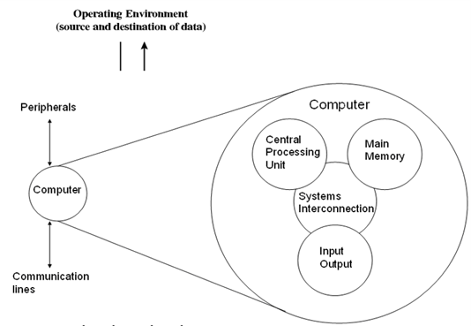
Figure 1 Computer architecture (Computer programming in c lab manual, 2024)

Figure 1 Computer architecture
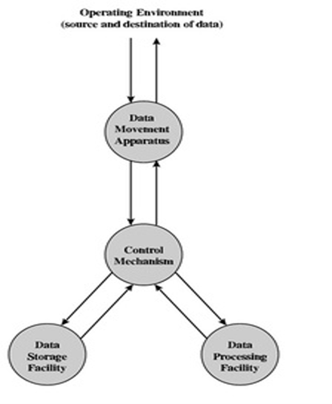
Figure 2 Computer data flow diagram (Prelim. (2024)

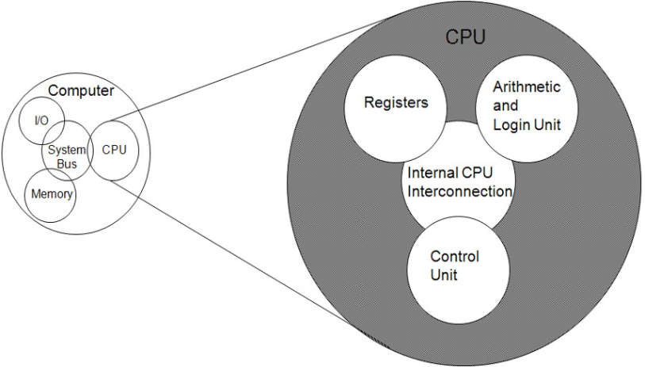
Figure 3 CPU components diagram (Computer programming in c lab manual, 2024)

Computer performance measurement system
Floating point operations per second (FLOPS):
· FLOPS is a measurement unit that is used to show the processing power of a computer (processor). This is done by measuring the number of floating-point calculations that the processor/computer can perform in one second. This helps determine the speed in which a processor/computer can perform operations (Lenovo, 2024).
· FLOPS can be calculated by multiplying the subsequent number of floating-point operations completed per second by the number of operations per instruction, this is then divided by execution time (Lenovo, 2024).
Table 1 Floating point operations per second table (Haq. A, 2015)

Table 2 Floating point operations per second table
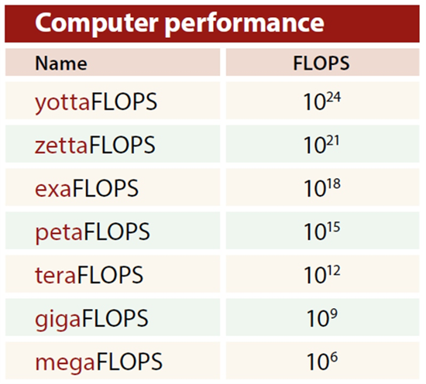

Example:
·An example of the difference in Flops can be seen when comparing petaFLOPS with teraFLOPS. Both are incredibly high measurements of processing speed but when it comes to an evaluation of speed and power, it takes one thousand teraFLOPS to make up a single petaflop. Therefore, the petaFLOP provides faster speed and stronger performance.
teraFLOPS (TFLOPS) = 10¹² FLOPS
petaFLOPS (PFLOPS) = 10¹⁵ FLOPS
An example of this can be shown when comparing the ASCI red (1996) and the IBM roadrunner (2008). Both of which were the first supercomputers to produce the different FLOPS respectively. Further to this although they were only built 12 years apart the IBM roadrunner could perform over 1000 times faster than the ASCI red (HP, 2024).
U:
- Servers’ height (vertical size) in unit of U
- 1U = 1.75 inches = 44.45 mm
- Example 4U = 7 inches = 177.8 mm (William Stalling, 2024)

Quantum Computing

By harnessing the qualities of quantum mechanics, quantum computing is at the forefront of computer science development.
· Using quantum mechanics, quantum computing can solve problems that exceed the ability of classical computers (IBM, 2024).

Four key principles:
· Superposition – this is the condition in which quantum particles can represent multiple possibility combinations rather than a sin gular possibility
· Entanglement – this is the process whereby quantum particles become correlated at an increased strength as opposed to what standard probability allows (azure.microsoft.com, 2024).
· Decoherence – this involves the process where quantum systems decay, change or collapse. This then converts the systems to single states which are measurable by regular physics.
· Interference – this is the occurrence in which entangled quantum states can interact and then produce an increased number of probabilities which are also less likely (IBM, 2024).
Qubits:
· Qubits are formulated by measuring and manipulating quantum particles.
· This includes Photons, electrons, trapped ions and atoms.
· Qubits are also used to engineer systems so that they are behave similar to a quantum particle- this includes superconducting circuits (azure.microsoft.com, 2024)
Classical vs Quantum computing:
·Quantum computers process large datasets simultaneously, whereby classical computers must compute each step of the calculation
· This is due to Quantum computers being ‘probabilistic’ and classical computers being ‘deterministic’.

Probabilistic = finding a range of possible outcomes
Deterministic = finding specific singular outcome
Table 3 Classical computing vs Quantum computing (CBINSIGHTS, 2021)

Table 4 Classical computing vs Quantum computing
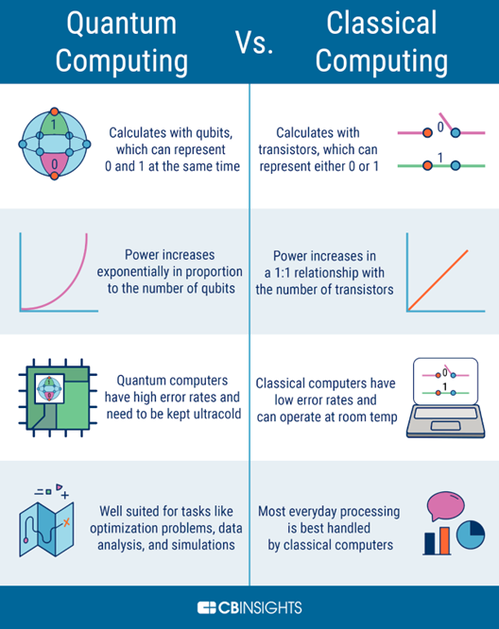

Computer arithmetic, number systems and algorithms

Decimal systems
Explanation of Decimal System, decimal digits, base (or radix) exponent (or power) and representation of integer and fractions:

What is the decimal system?
- The decimal system is a positional numbering system using 10 as the base (radix) and then requiring 10 different numerals 0 through to 9 (Lenovo, 2024).
- The decimal system also requires the Prescence of a decimal point to represent the decimal fractions; the required numerals used to denote a number that takes a different place values depending on position (Britannica, 2024).
- A decimal fraction is the fraction in which the denominator is equal to or a multiple of 10. For example: 00, 1000, 1000, 10000 (Byjus, 2024).

Binary systems

Explanation of Binary System, binary digits, base, exponent and representation of integer and fractions?

- The binary numbering system or positional numeral system that will use 2 as its base and requires only two digits - 0 and 1 instead of 10 digits like the decimal system.
- As a result of this the numbers from 0 to 10 are in binary: 0, 1, 10, 11, 100, 101, 110, 111, 1000, 1001, and 1010 (Britannica, 2024).
- A binary digit (or Bit) is the smallest form of measurement within a computer.
- A binary digit is used for recording (storing) information and has an individual value of either 1 or 0.
- A binary digit is typically used to store data or produce instructions in groups of bytes.

Hexadecimal systems

Explanation of Hexadecimal System, hexadecimal digits, base, exponent and representation of hexadecimal integer numbers.

- Hexadecimal (or Hex) is a system that utilises base 16, Binary digits are grouped into subsequent sets of four. Each combination of four is then assigned a symbol (William Stalling 2024).
- A sequence of hexadecimal digits can be described as representing base 16 (IONOS, 2024).
- The 16 symbols used are referred to as Hexadecimal digits. The table below showcases the 16 symbols and their respective binary digits.

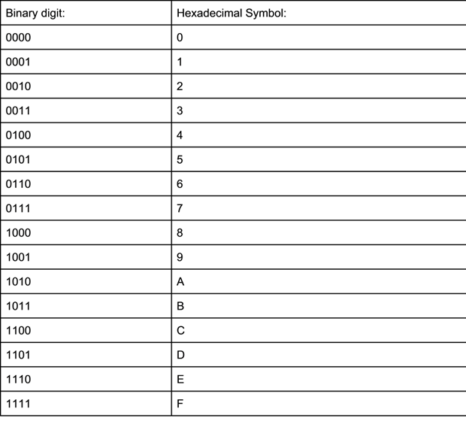
Table 5 Hexadecimals

Table 6 Hexadecimals

Computer arithmetic representation

Table 7 Hexadecimal, decimal and binary representation including workings.
bit - Bit or ‘Binary Digit’ is the smallest unit of binary information. It is represented in 1 and 0. (IONOS, 2024).
byte - A byte is equal to 8 bits and is predominantly used to represent storage size. A byte can represent 256 (2⁸) different states. (IONOS, 2024).

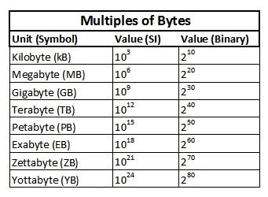
Table 10 Bits breakdown (IONOS, 2022)

Table 11 Bits breakdown
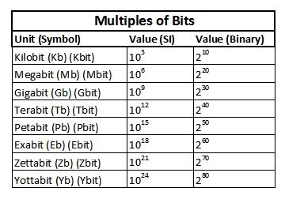
Table 8 Byte breakdown (IONOS, 2022)

Table 9 Byte breakdown

Floating points

float- A float is a type of data consisting of a number that is not an integer. In computer programming, when more precision is needed than an integer can provide a float is used. (Technopedia, 2020)
double- a double provides double the amount of precision as a float; float has a precision of 15-point decimal places as opposed to a float 7.
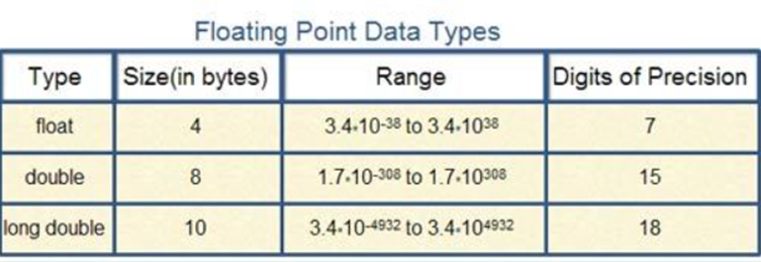
Long Double - Long double is more precise than a double float.
Table 12 Floating points (computer notes, 2013)

Table 13 Floating points

Computer processors, performance, energy efficiency and cooling
Table 14 Computer processor terminologies




Memory types
Table 16 Memory types (Lenovo, 2024)

Table 17 Memory types


Processor performance

Benefits of CPU Lithography size reduction.

- Lower nanometre Lithography in manufacturing of CPU components involves the technology used within the process of creating the transistors on a chip. The table below outlines the key benefits of having a lower nm lithography:

Table 18 CPU lithography (Intel, 2024)

Table 19 CPU lithography


Max Memory Size and what determines Max Memory Size

Intel® Turbo Boost Technology and its role for system performance.
- Intel turbo boost is an accelerator technology that increases processor and graphics performance for peak loads. This is done automatically by pushing processor cores to increase run speed higher than the recommended operating frequency. This is done if the cores are running below current, temperature and power limits. The operation of intel's turbo technology and the time active is dependent on the operating environment and workload (Intel, 2022).

Intel CPU comparison (www.scan.co.uk, 2024):
Table 20 Intel CPU comparison (Intel, 2024)

Table 21 Intel CPU comparison
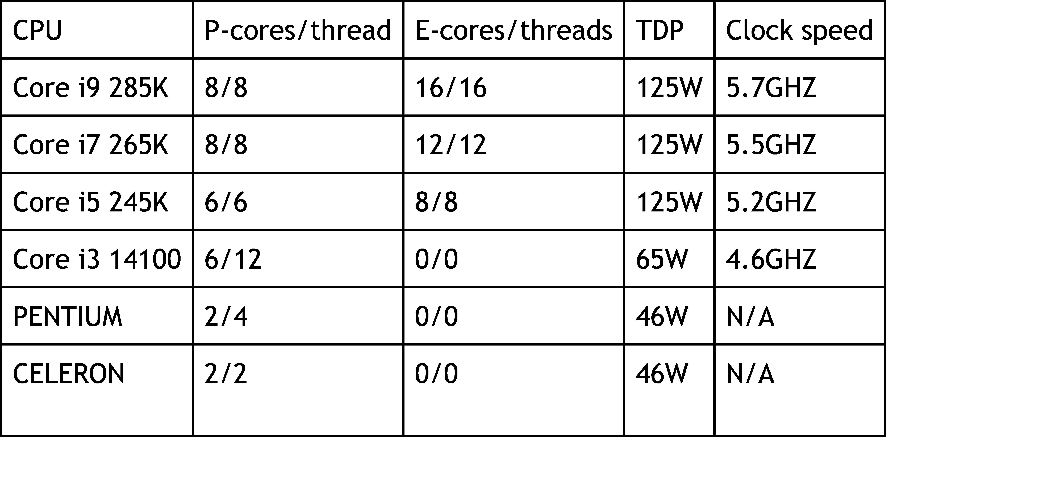


AMD CPU comparison (www.scan.co.uk, 2024.):
Table 22 AMD CPU comparison (AMD, 2024)

Table 23 AMD CPU comparison

Apple Bionic chip:
Table 24 Apple bionic chip (Apple, 2024)

Table 25 Apple bionic chip
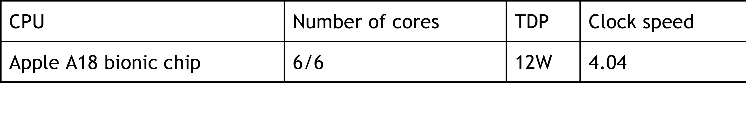


Table 26 Apple bionic chip strengths and weaknesses

Table 27 Apple bionic chip strengths and weaknesses

Processor cooling
For this task internet research should be done. Discuss and compare air-cooling and water-cooling methods. Identify strengths and limitations:

Air cooling:
- In air cooling, there is a transfer of heat from the integrated heat spreader (IHS) of the CPU, and then through an applied thermal paste. This is then pushed through a conductive base plate which is commonly made using aluminium or copper. From the baseplate of the cooling system, the thermal energy then moves through the heat pipes attached. The heat pipes are formulated to conduct the heat from one specific location to another and the cooler air is usually circulated using a fan (Intel, 2023).
- The effectiveness of air cooling is dependent on materials used (depending on material and conductivity) as well as quantity of fans and size of cooling system attached to the heat sink (larger fans usually dissipate heat more effectively) (Intel, 2023).

Liquid cooling:
- Similar to air cooling the baseplate is connected to the Integrated heat spreader of the CPU. This is connected using a layer of thermal paste. As a result of this there is an increase in heat conductivity between two surfaces. The metal plate is a section of the water block (WB) and is created to fill with coolant (Intel, 2023).
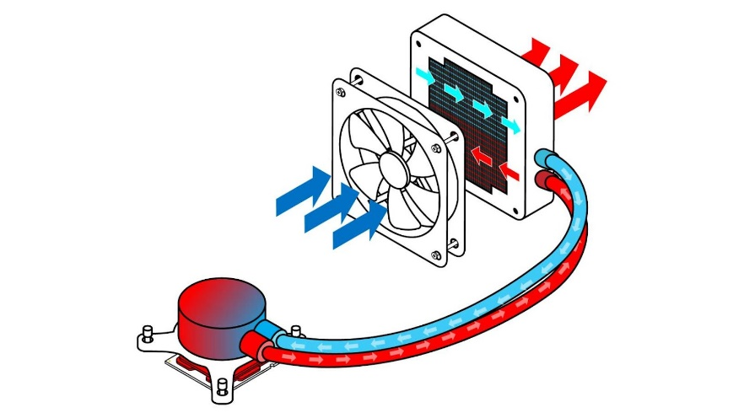
- heat is taken from the baseplate, using coolant that absorbs the heat as it is circulated through the required WB. The coolant then runs throughout the system and then through one of the two tubes to the radiator. There is then a fan situated near the radiator which exposes the tube to air in which the liquid cools, other fans are then used to dissipate the air and push it away from the cooler. The coolant then re-enters the WB and the cycle starts again (Intel, 2023).
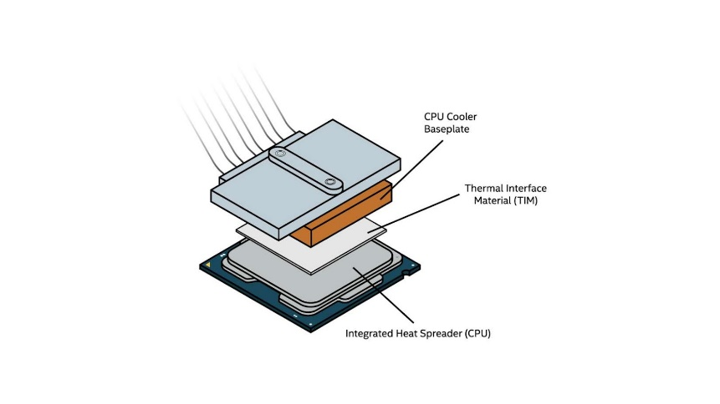
Figure 4 Air cooling diagram (Intel, 2024)

Figure 5 Liquid cooling diagram (Intel, 2024)

Table 28 Air cooling vs Liquid cooling ((Kingston Technology Company, 2024)

Table 29 Air cooling vs Liquid cooling

Processor coolers comparison:
Noctua NF-A15 PWM Premium CPU Cooler and iCUE H100i RGB ELITE Liquid CPU Cooler
Table 30 Noctua vs ICUE table (Noctua, 2024) (ICUE, 2024)

Storage

Hard Disk Drives (HDD)
An HDD is an external or internal memory component utilised for storing data. HDDs are non-volatile types of storage meaning that they manage to retain data even when the power is off.
A hard disk drive contains 2 components:
- Platter - this is a magnetic disk (usually circular) that contains tracks and sectors that hold data
- Actuator arm - this reads and writes data by moving across a platter
The platter spins on a spindle to increase the speed of reading and writing data. As well as this the data sectors are spread out randomly (fragmented) (Crucial, 2024).

Solid State Drives (SSD)
SSD is a form of data storage that uses integrated circuit assemblies to retain data. Unlike traditional storage including hard drives or HHD’s, solid state drives have no moving parts. As a result of this, SSD provides advantages covering, performance, reliability, speed and energy efficiency. SSD is made up of the following components:
- Data is stored in NAND flash chips.
- The SSD data controller or cache controller controls the read and write functions as well as the data distribution.
- When accessing data from a computer, the data controller retrieves the necessary data from the appropriate cells.
- To write data, the controller identifies available cells and stores the data electronically.
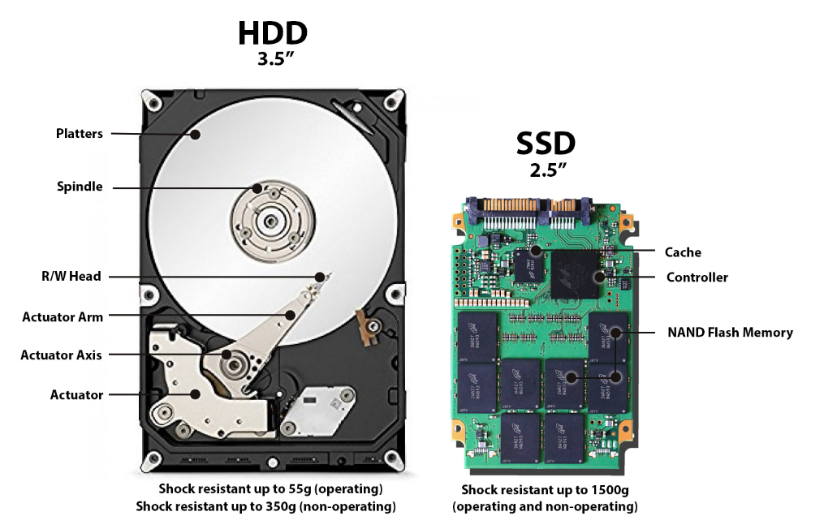
Due to the process as well as the lack of moving parts, the use of SSD’s is much faster than that of HDD’s. As well as this, it also increases the power efficiency and energy consumption proving more reliable overall (HP, 2018).

Figure 6 HDD and SSD diagram (Bauer, 2018)
Table 32 SSD vs HDD (AWS, 2024)

Table 33 Storage device comparison

Storage evaluation and recommendation:
Table 34 Storage recommendation table

See appendix 1 for Summary discussion

NAS – models, applications and evaluation
Table 35 NAS characteristics (William stalling, 2024)

Raid Models
Table 36 Raid models (Prepressure, 2011)

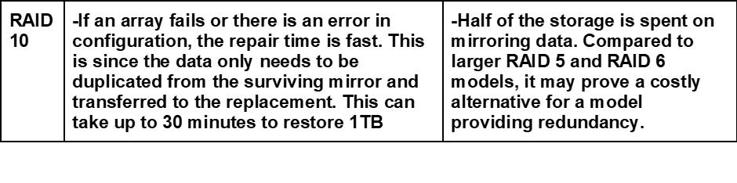

NAS and Cloud storage usage scope and purpose
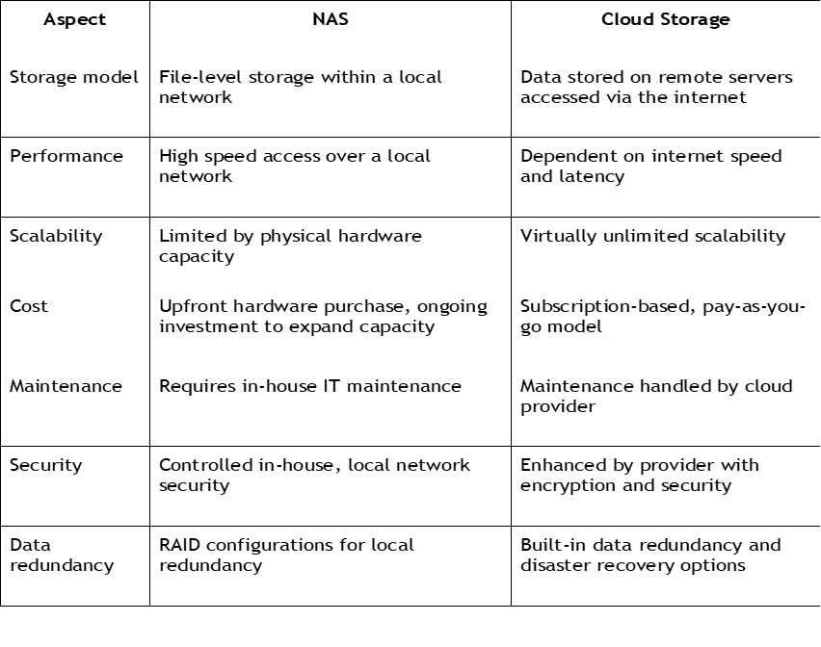
Table 37 NAS vs Cloud computing table (Subramanian, V. 2024).

Cloud vs Nas:
For supporting operations and clarifying what method should be used for what instance it is important to identify usage. NAS creates fast and local accesses as well as control and cost efficiency. This is better suited to operations that are localised and with stable on-site storage needs. Cloud storage provides incredible scalability options, flexibility, maintenance free operations and remote access. This is better suited to a consumer who's looking to scale storage needs flexibly on a pay as you go basis and needs to access data remotely as opposed to on site. For most, operations can be completed using a hybrid system whereby both are utilised, and benefits can be derived from both sources (Subramanian, 2024).

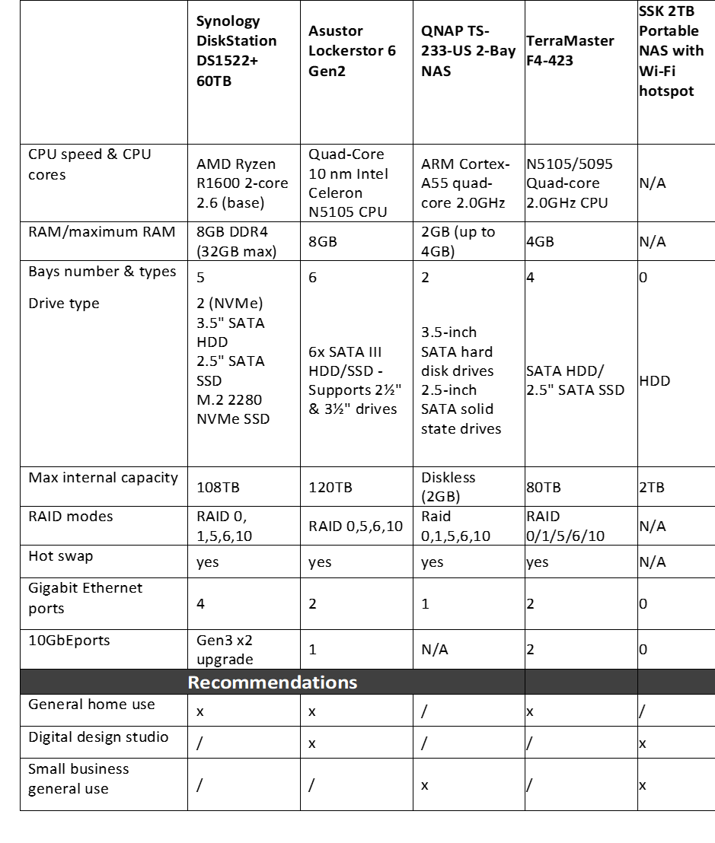
Nas comparison
Table 38 Nas comparison (Santo, J. 2019)

Advanced Concepts and Algorithms

Sorting algorithms comparison
Table 39 Sorting algorithms comparison
See appendix for Bubble, shell and merge python coding methods.
How Bremermann's Limit affects computations?
In 1962 H.J Bremermann formulated a limit for computational rate (or bit rate) for any processing system (computer). Bremermann proposed that the limit was Mc2/h = ~ (M/gram) 1047 bits per second, this is with the ‘M’ as mass, ‘C’ as speed of light and ‘h’ as Planck's constant. This resulted in a limit for the maximum processing rate being formulated and thus a ceiling was created regarding what a processor could achieve (Gennady Gorelik, 2024).
Approaches and solutions which could help to cope with limitations:
The implementation of algorithms and quantum computing can expand limitations. This is due to the ability to perform tasks at a smaller level whilst maintaining power (IBM, 2024).

Advanced algorithms
Table 40 Advanced algorithm (Urbanowicz and Moore, 2013)
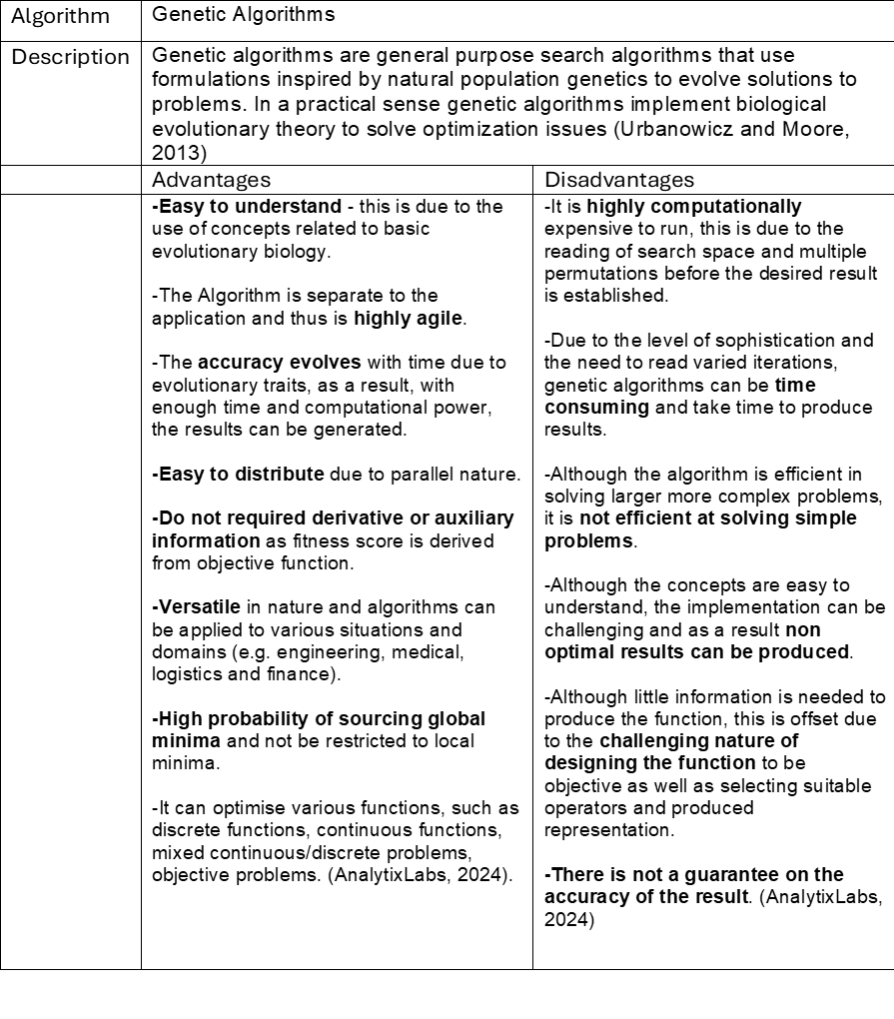

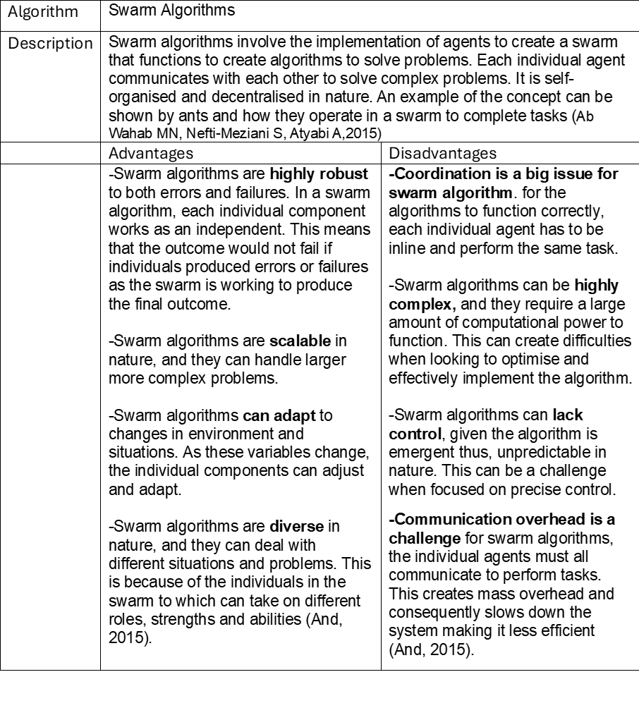
swarm algorithms
Table 41 swarm algorithms (Ab Wahab MN, Nefti-Meziani S, Atyabi A, 2015)

Evolutionary algorithms
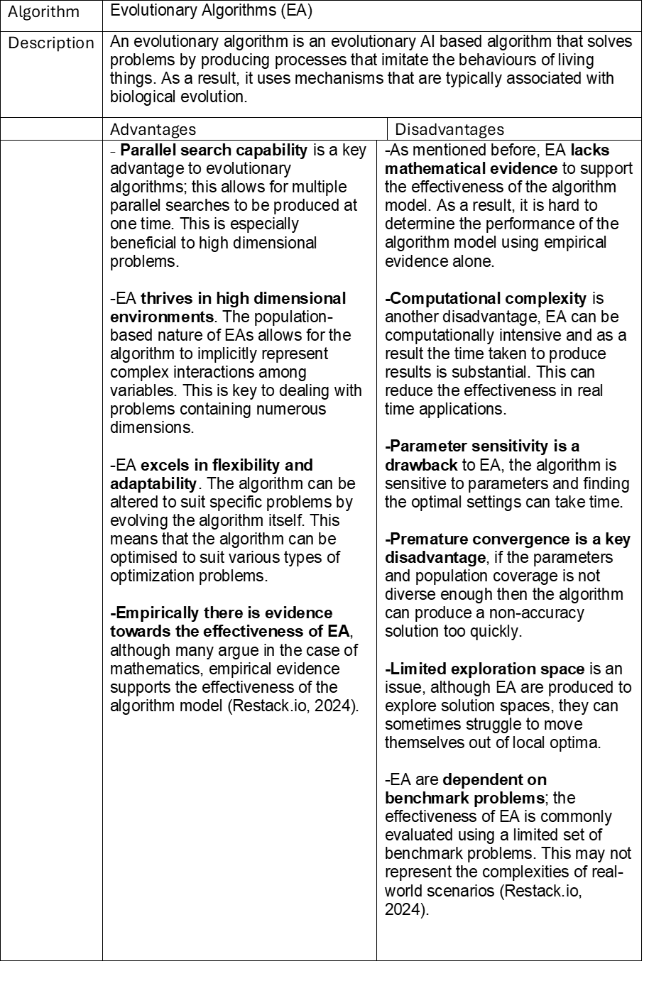
Table 42 Evolutionary algorithms (AnalytixLabs 2024)

Heuristic algorithms
Table 43 Heuristic algorithms (Carruego, 2024)
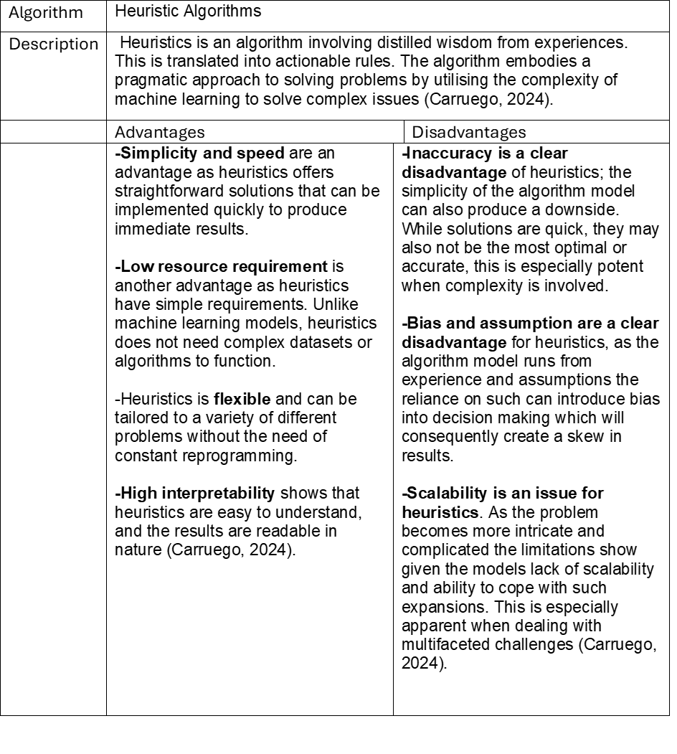

Adaptive algorithms
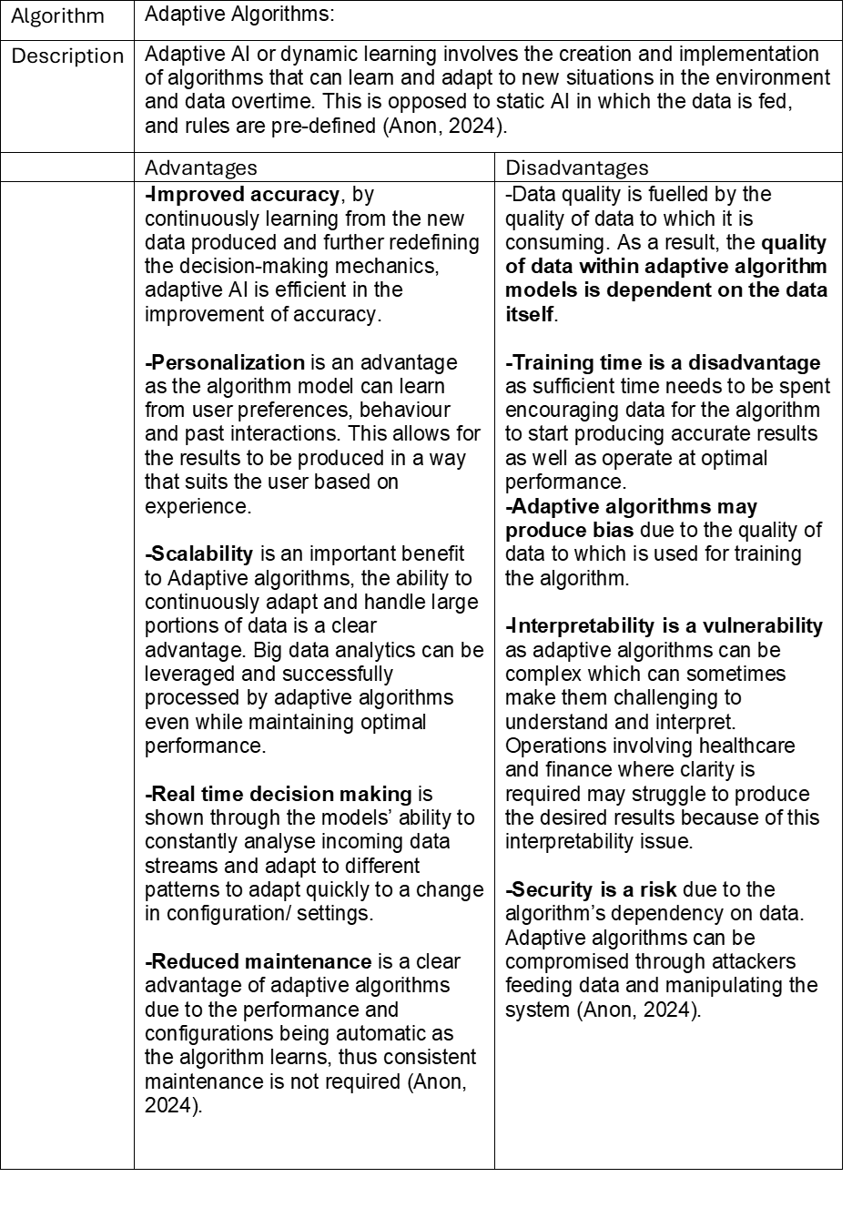
Table 44 Adaptive algorithms (Anon, 2024)

Conclusion
This research project has successfully addressed the concepts of computer fundamentals. The 6 different subheadings have been effectively explored and detailed information has been given for each using a range of sources. The sections successfully explored are as follows:
1 Computer structure functioning and architecture
2 Computer arithmetic, number systems, algorithms
3 Computer processors, performance, energy efficiency and cooling
4 Storage principles, types, and evaluation
5 NAS – models, applications, and evaluation
6 Advanced concepts and algorithms
These sections were supported by appropriate figures and tables to illustrate the key aspects related to the topics. The purpose of this document is to provide information related to the fundamentals of computing and through the development and the exploration of the 6 sections mentioned this has been achieved.

References

(Anon, 2024). What does it mean to hot swap in computing? [online] Available at: https://www.techtarget.com/whatis/definition/hot-swap. Accessed [November 12th 2024]
Ab Wahab MN, Nefti-Meziani S, Atyabi A (2015) A Comprehensive Review of Swarm Optimization Algorithms. PLOS ONE 10(5): e0122827. https://doi.org/10.1371/journal.pone.0122827[November 12th 2024]

Amazon Web Services, Inc. (2024). What is NAS (Network-Attached Storage)? - Amazon Web Services. [online] Available at: https://aws.amazon.com/what-is/nas/. Accessed [November 20th 2024]
Amos, Z. (2024). SSD vs. HDD: How the Choice of Storage Affects Developer Workflows. [online] dzone.com. Available at: https://dzone.com/articles/ssd-vs-hdd-how-the-choice-of-storage-affects-devel [Accessed 14 Nov. 2024].
AnalytixLabs (2024). A Complete Guide to Genetic Algorithm — Advantages, Limitations & More. [online] Medium. Available at: https://medium.com/@byanalytixlabs/a-complete-guide-to-genetic-algorithm-advantages-limitations-more-738e87427dbb. [November 12th 2024]

AnalytixLabs (2024). A Complete Guide to Genetic Algorithm — Advantages, Limitations & More. [online] Medium. Available at: https://medium.com/@byanalytixlabs/a-complete-guide-to-genetic-algorithm-advantages-limitations-more-738e87427dbb. Accessed [November 20th 2024]
And, A. (2015). Advantages And Challenges Of Swarm Intelligence - FasterCapital. [online] FasterCapital. Available at: https://fastercapital.com/topics/advantages-and-challenges-of-swarm-intelligence.html [Accessed 17 Nov. 2024].
Anon, (2024). Adaptive AI: Unlocking Benefits and Overcoming Challenges - Apexon. [online] Available at: https://www.apexon.com/blog/adaptive-ai-unlocking-benefits-and-overcoming-challenges/.[November 12th 2024]

ASUSTOR. (2024). ASUSTOR. [online] Available at: https://www.asustor.com/en/knowledge/detail/?id=&group_id=1216 [Accessed 15 Nov. 2024].
AWS (2024). What is Caching and How it Works | AWS. [online] Amazon Web Services, Inc. Available at: https://aws.amazon.com/caching/.[November 12th 2024]

azure.microsoft.com. (2024). What is a Qubit? | Microsoft Azure. [online] Available at: https://azure.microsoft.com/en-gb/resources/cloud-computing-dictionary/what-is-a-qubit. Accessed [November 20th 2024]

Bauer, R. (2018). HDD vs SSD: What Does the Future for Storage Hold? [online] Backblaze Blog | Cloud Storage & Cloud Backup. Available at: https://www.backblaze.com/blog/ssd-vs-hdd-future-of-storage/.[November 12th 2024]
Bloom, G., Leontie, E., Narahari, B. and Simha, R. (2012). Hardware and Security. Handbook on Securing Cyber-Physical Critical Infrastructure, [online] pp.305–331. doi:https://doi.org/10.1016/b978-0-12-415815-3.00012-1. Accessed [November 20th 2024]
Britannica (2024), The Editors of Encyclopaedia. "decimal system". Encyclopedia Britannica, 17 Oct. 2024, available at: https://www.britannica.com/science/decimal (Accessed 21 October 2024.)
Byjus (2024), Decimal fractions, available at: https://byjus.com/maths/decimal-fractions/ (accessed: 21st October 2024)
Carruego, M. (2024). Choosing the Right Algorithm: Machine Learning vs. Heuristics. [online] Medium. Available at: https://mikecarruego.medium.com/choosing-the-right-algorithm-machine-learning-vs-heuristics-dc0b65e97d98. [November 12th 2024]
CB insights (2024) Quantum Computing Vs. Classical Computing In One Graphic, available at: https://www.cbinsights.com/research/quantum-computing-classical-computing-comparison-infographic/ (accessed: 21st October 2024)
CBINSIGHTS (2021). Quantum Computing Vs. Classical Computing In One Graphic. [online] CB Insights Research. Available at: https://www.cbinsights.com/research/quantum-computing-classical-computing-comparison-infographic/.[November 12th 2024]

"‌Computer Notes. (2013). Data Types – Explain Data Type in C++. [online] Available at: https://ecomputernotes.com/cpp/introduction-to-oop/data-types-in-cpp. Accessed [November 11th 2024]

‌ "
Computer programming in c lab manual - Scientific Figure on ResearchGate. Available from: https://www.researchgate.net/figure/The-computer-top-level-structure-1_fig1_306482093 [accessed 11 Dec 2024]
CORSAIR. (2024). iCUE H100i RGB ELITE Liquid CPU Cooler. [online] Available at: https://www.corsair.com/uk/en/p/cpu-coolers/cw-9060058-ww/icue-h100i-rgb-elite-liquid-cpu-cooler-cw-9060058-ww?srsltid=AfmBOoptcN--Uj2lWuBz7U_0sROWI9DzmzxDHpo8Mh8UvOBzfJUDeXAn [Accessed 14 Nov. 2024].
CPU monkey (2024). Apple A18 Pro Benchmark, Test and specs. [online] Cpu-monkey.com. Available at: https://www.cpu-monkey.com/en/cpu-apple_a18_pro [Accessed 13 Nov. 2024].
Crucial. (2024). What is a Hard Drive? [online] Available at: https://uk.crucial.com/articles/pc-builders/what-is-a-hard-drive. [November 12th 2024]

GeeksforGeeks (2014). Bubble Sort Algorithm. [online] GeeksforGeeks. Available at: https://www.geeksforgeeks.org/bubble-sort-algorithm/. Accessed [November 20th 2024]
GeeksforGeeks (2014). Shell Sort. [online] GeeksforGeeks. Available at: https://www.geeksforgeeks.org/shell-sort/. Accessed [November 20th 2024]
GeeksforGeeks (2018). Merge Sort - GeeksforGeeks. [online] GeeksforGeeks. Available at: https://www.geeksforgeeks.org/merge-sort/.[November 12th 2024]
Gennady Gorelik (2024). Bremermann’s Limit and cGh-physics. [online] Available at: https://arxiv.org/vc/arxiv/papers/0910/0910.3424v2.pdf [Accessed 17 Nov. 2024].
Gillis, A. (2021). What is RAID? [online] SearchStorage. Available at: https://www.techtarget.com/searchstorage/definition/RAID. [November 12th 2024]

Haq, A. (2015). Supercomputers for Beginners - Part I - GeoExpro. [online] GeoExpro. Available at: https://geoexpro.com/supercomputers-for-beginners-part-i/ [Accessed 11 Dec. 2024].
HP (2024) What's the Computing Difference Between a TeraFLOPS and a PetaFLOPS, avaialble at: https://www.hp.com/us-en/shop/tech-takes/computing-difference-between-teraflops-and-petaflops (accessed: 21st October 2024)
https://community.intel.com/t5/user/viewprofilepage/user-id/375831 (2024). Max memory speed spec. [online] Intel.com. Available at: https://community.intel.com/t5/Processors/Max-memory-speed-spec/td-p/1622311 [Accessed 7 Nov. 2024].
I3international.com. (2016). HDD1 | i3 International. [online] Available at: https://www.i3international.com/products/view/HDD1 [Accessed 14 Nov. 2024].
I3international.com. (2016). HDD2 | i3 International. [online] Available at: https://www.i3international.com/products/view/HDD2 [Accessed 14 Nov. 2024].
IBM (2024) What is quantum computing? available at: https://www.ibm.com/topics/quantum-computing (accessed 21st october 2024)
Insight UK. (2015). Product. [online] Available at: https://uk.insight.com/en_GB/shop/product/DELL-1TB3DTLC-F22/origin/DELL-1TB3DTLC-F22/Origin-Storage-SSD-1-TB-SATA-6Gbs/?srsltid=AfmBOorVQDpayrvrzdIHG6KM48ONNAWlCHvtrJF5-HA9oiLppETS44Ym [Accessed 14 Nov. 2024].
Insight UK. (2015). Product. [online] Available at: https://uk.insight.com/en_GB/shop/product/INSSD2TM2230G4/INTEGRAL/INSSD2TM2230G4/Integral--SSD--2-TB--PCIe-40-x4-NVMe/#tab-specifications [Accessed 14 Nov. 2024].
Intel (2023). CPU Cooler: Liquid Cooling Vs Air Cooling. [online] Intel. Available at: https://www.intel.com/content/www/us/en/gaming/resources/cpu-cooler-liquid-cooling-vs-air-cooling.html. [November 12th 2024]
Intel (2023). Intel | Data Center Solutions, IoT, and PC Innovation. [online] Intel. Available at: https://www.intel.com/content/www/us/en/homepage.html. Accessed [Novemeber 14th 2024]
Intel (2024) Demystifying PC Technology: RAM vs. Processor, available at: https://www.intel.com/content/www/us/en/business/small-business/resources/ram-vs-processor.html (accessed: 21st October 2024)
Intel. (2022). What Is Intel® Turbo Boost Technology and How Does It Work? [online] Available at: https://www.intel.com/content/www/us/en/support/articles/000030893/processors.html [Accessed 13 Nov. 2024].
Intel. (2023). How to Know Which Processors Support ECC Memory. [online] Available at: https://www.intel.com/content/www/us/en/support/articles/000096922/processors.html [Accessed 7 Nov. 2024].
Intel. (2024). How Intel Technologies Boost Your CPU’s Performance. [online] Available at: https://www.intel.com/content/www/us/en/gaming/resources/how-intel-technologies-boost-cpu-performance.html. [November 12th 2024]
Intel. (2024). Intel® CoreTM Ultra 9 Processor 288V (12M Cache, up to 5.10 GHz). [online] Available at: https://www.intel.com/content/www/us/en/products/sku/240961/intel-core-ultra-9-processor-288v-12m-cache-up-to-5-10-ghz/specifications.html [Accessed 7 Nov. 2024].
Intel. (2024). Thermal Design Power (TDP) in Intel® Processors. [online] Available at: https://www.intel.com/content/www/us/en/support/articles/000055611/processors.html. Accessed [November 20th 2024]
invent (2024). How the A18 Chip and AI Enhance User Experience: iPhone 16. [online] iNvent Store. Available at: https://inventstore.in/how-the-a18-chip-and-ai-enhance-user-experience-on-the-iphone-16/ [Accessed 13 Nov. 2024].
IONOS (2022). What is a bit? Bits and bytes explained. [online] IONOS Digital Guide. Available at: https://www.ionos.co.uk/digitalguide/websites/web-development/what-is-a-bit/. Accessed [November 11th 2024]
IONOS (2024) The hexadecimal system, available at: https://www.ionos.co.uk/digitalguide/server/know-how/hexadecimal-system/ (accessed: 22nd October 2024)
IONOS (2024) What is a bit? Bits and bytes explained, available at: https://www.ionos.co.uk/digitalguide/websites/web-development/what-is-a-bit/ (accessed: 23rd October 2024)
Joseph amar (2024) Computer architecture and organisation, available at: https://josephsamar.weebly.com/prelim.html (accessed 21st October 2024)
Kingston Technology Company. (2024.). Air cooling Vs. liquid cooling in PC builds. [online] Available at: https://www.kingston.com/unitedkingdom/en/blog/gaming/air-vs-liquid-cooling-pc-builds. [November 12th 2024]
Kingston Technology Company. (2024). Air cooling Vs. liquid cooling in PC builds. [online] Available at: https://www.kingston.com/unitedkingdom/en/blog/gaming/air-vs-liquid-cooling-pc-builds. [November 12th 2024]
Lenovo (2024) What are floating-point operations per second (FLOPS)? available at: https://www.lenovo.com/gb/en/glossary/flops/?orgRef=https%253A%252F%252Fwww.google.com%252F (accessed: 21st October 2024)
Lenovo (2024) What is decimal? available at: https://www.lenovo.com/us/en/glossary/decimal/?orgRef=https%253A%252F%252Fwww.google.com%252F (accessed: 21st October 2024)
Lenovo.com. (2021). CPU core: What is a Core in a CPU | How many CPU Cores do i have | Lenovo UK. [online] Available at: https://www.lenovo.com/gb/en/glossary/cpu-core/?orgRef=https%253A%252F%252Fwww.google.com%252F&srsltid=AfmBOoo57rNFtzYncsRS2HsMJdtOLDGcTDb9C-T-EiayM2JiaN_QXzRz [Accessed 6 Nov. 2024].
AnalytixLabs (2024). A Complete Guide to Genetic Algorithm — Advantages, Limitations & More. [online] Medium. Available at: https://medium.com/@byanalytixlabs/a-complete-guide-to-genetic-algorithm-advantages-limitations-more-738e87427dbb. [November 12th 2024]
Noctua.at. (2024). NF-A15 PWM. [online] Available at: https://noctua.at/en/products/fan/nf-a15-pwm [Accessed 14 Nov. 2024].
Optimizing Server Refresh Cycles: The Case for Circular Economy With an Aging Moore's Law - Scientific Figure on ResearchGate. Available from: https://www.researchgate.net/figure/mpact-of-CPU-lithography-on-performance-and-idle-power-n-represents-the-number-of_fig1_346593629 [accessed 11 Dec 2024]
Pavlovic, D. (2018). What is a Solid-State Drive (SSD)? [online] Hp.com. Available at: https://www.hp.com/us-en/shop/tech-takes/what-is-an-ssd. [November 12th 2024]
Prelim. (2024). Computer Architecture and Organization. [online] doi:https://doi.org/1070577/929278.jpg?194. Accessed [November 11th 2024]
Prepressure (2011). RAID Level 0, 1, 5, 6 and 10 | Advantage, disadvantage, Use. [online] Prepressure.com. Available at: https://www.prepressure.com/library/technology/raid. Accessed [November 20th 2024]
QNAP Systems, Inc (2024). TS-233 | Hardware Specs. [online] QNAP Systems, Inc. - Network Attached Storage (NAS). Available at: https://www.qnap.com/en-uk/product/ts-233/specs/hardware [Accessed 17 Nov. 2024].
Quora. (2019). What’s the benefit of having a lower nm lithography CPU? [online] Available at: https://www.quora.com/What-s-the-benefit-of-having-a-lower-nm-lithography-CPU [Accessed 7 Nov. 2024].
Research gate (2016) Computer programming in c lab manual - Scientific Figure on ResearchGate. Available from: https://www.researchgate.net/figure/The-computer-top-level-structure-1_fig1_306482093 [accessed 21 Oct 2024]
Restack.io. (2024). Pros And Cons Of Evolutionary Algorithms | Restackio. [online] Available at: https://www.restack.io/p/evolutionary-algorithms-answer-pros-cons-cat-ai [Accessed 18 Nov. 2024].
rs-online (2024). A Guide To Ethernet Cables & How to Use | RS. [online] Available at: https://uk.rs-online.com/web/content/discovery/ideas-and-advice/ethernet-cables-guide. Accessed [November 20th 2024]
Santo, J. (2019). The Best NAS (Network Attached Storage) Devices for 2019. [online] PCMag UK. Available at: https://uk.pcmag.com/nas/14710/the-best-nas-network-attached-storage-devices. Accessed [November 20th 2024]
Seagate.com. (2024). System Overview | Seagate US. [online] Available at: https://www.seagate.com/gb/en/manuals/network-storage/4-bay-nas/system-overview/ [Accessed 15 Nov. 2024].
SearchNetworking. (2024). What is 10 Gigabit Ethernet (10 GbE)? [online] Available at: https://www.techtarget.com/searchnetworking/definition/10-Gigabit-Ethernet. Accessed [November 20th 2024]
Subramanian, V. (2024). NAS vs. Cloud Storage: Which Solution Fits Your Business Needs? [online] Backblaze Blog | Cloud Storage & Cloud Backup. Available at: https://www.backblaze.com/blog/nas-vs-cloud-storage-which-solution-fits-your-business-needs/. Accessed [November 20th 2024]
Technopedia (2020) Float, avaialable at: https://www.techopedia.com/definition/23980/float-computer-science (accessed: 23rd October 2024)
Techopedia (2017) Understanding Bits, Bytes and Their Multiples, availabale at: https://www.techopedia.com/2/29184/development/programming-languages/understanding-bits-bytes-and-their-multiples (accessed: 23rd October 2024)
techopedia (2023) What is a binary digit? avaialble at: https://www.techopedia.com/definition/2678/binary-digit-bit (accessed: 21st October 2024)
the Guardian. (2018). What is the best laptop drive for students? [online] Available at: https://www.theguardian.com/technology/askjack/2018/jun/21/what-is-the-best-laptop-drive-for-students. Accessed [November 20th 2024]
Thomas-Krenn.AG (2012). Overview of the Intel VT Virtualization Features. [online] Thomas-krenn.com. Available at: https://www.thomas-krenn.com/en/wiki/Overview_of_the_Intel_VT_Virtualization_Features. Accessed [November 20th 2024]
Urbanowicz, R.J. and Moore, J.H. (2013). Learning Classifier Systems: The Rise of Genetics-Based Machine Learning in Biomedical Data Mining. Elsevier eBooks, [online] pp.265–311. doi:https://doi.org/10.1016/b978-0-12-401678-1.00009-9. Accessed [November 20th 2024]
Walilko, A. (2023). The Difference Between CPU Cores and Threads. [online] Liquid Web. Available at: https://www.liquidweb.com/blog/difference-cpu-cores-thread/. Accessed [November 20th 2024]
William Stalling (2000) Number systems, 2000
William Stalling (2010) Computer organization and structure designing and performance, eight addition, 2010
www.lenovo.com. (2024). What is Computer Memory? Types of Computer Memory Explained | Lenovo US. [online] Available at: https://www.lenovo.com/us/en/glossary/computer-memory/?orgRef=https%253A%252F%252Fwww.google.com%252F. Accessed [November 20th 2024]
www.scan.co.uk. (2024). AMD Processors Comparison | Buyers Guide | SCAN UK. [online] Available at: https://www.scan.co.uk/buying-guides/cpu/amd-processors. Accessed [November 20th 2024]
www.scan.co.uk. (2024). Intel CPU Buyers Guide - Intel Processors Comparison | SCAN UK. [online] Available at: https://www.scan.co.uk/buying-guides/cpu/intel-processors. Accessed [November 20th 2024]

Appendix:

Appendix 1 storage comparison.
Student laptop:
- SSD - SSD takes up less space than HDD, this is beneficial for a compact laptop. As well as this, SSD has more power efficiency, as a result of this battery life is increased. SSD also increases the load speed and save speed of data which is ideal for student work. Finally, SSD is more durable than HDD and as a result it is more likely to survive being put in and out of a rucksack full of books. Although a reduction in storage space when compared to HDD, due to the implementation of the cloud and cloud storage, the missing storage can be supported elsewhere.
- NVMe SSD is an option, and it will perform to a higher level than SSD but given the increased price it is not necessary for a student laptop as the average student will not be running anything that will require the NVMe SSD (theguardian,2018).
Software developer:
- SSD and NVMe SSD - for software developers I recommend SSD and NVMe SSD, this is due to the importance of speed and performance when running high level code. SSD will be good for lighter coding projects and NVMe SSD will be more beneficial to large more complicated coding projects.
- I have not recommended HDD given that although more storage may be available, as projects become more complicated and more code is being compiled from storage, the speed and performance will decrease, and HDD may struggle to keep up with future software’s (Amos, 2024).
Digital Designer Desktop:
- NVMe SSD - for digital designer desktop I recommend NVMe given the nature of the work, and the storage needed to accommodate for the data being written and read. Digital designers will require mass data to be stored and run and as a result the increased speed and performance is suited to NVMe SSD. I would not recommend HDD as although it has a large storage capacity, the performance will not be good enough. And although for lighter projects SSD can be used, for a professional or someone who performs a lot of digital designs, the performance is better suited to NVMe SSD (Amos, 2024).

Appendix 2 Merge sort python code:
Merge sort:
def merge(arr, left, mid, right):
n1 = mid - left + 1
n2 = right - mid
# Create temp arrays
L = [0] * n1
R = [0] * n2
# Copy data to temp arrays L[] and R[]
for i in range(n1):
L[i] = arr[left + i]
for j in range(n2):
R[j] = arr[mid + 1 + j]
i = 0 # Initial index of first subarray
j = 0 # Initial index of second subarray
k = left # Initial index of merged subarray
# Merge the temp arrays back
# into arr[left..right]
while i < n1 and j < n2:
if L[i] <= R[j]:
arr[k] = L[i]
i += 1
else:
arr[k] = R[j]
j += 1
k += 1
# Copy the remaining elements of L[],
# if there are any
while i < n1:
arr[k] = L[i]
i += 1
k += 1
# Copy the remaining elements of R[],
# if there are any
while j < n2:
arr[k] = R[j]
j += 1
k += 1
def merge_sort(arr, left, right):
if left < right:
mid = (left + right) // 2
merge_sort(arr, left, mid)
merge_sort(arr, mid + 1, right)
merge(arr, left, mid, right)
def print_list(arr):
for i in arr:
print(i, end=" ")
print()
# Driver code
if __name__ == "__main__":
arr = [200, 123, 200, 600, 350, 100, 700, 1000, 23453,35355,366432,2455353,345242,34534,324523,23552]
print("Given array is")
print_list(arr)
merge_sort(arr, 0, len(arr) - 1)
print("\nSorted array is")
print_list(arr)

Appendix 3 Shell sort:
# Python3 program for implementation of Shell Sort
# Python3 program for implementation of Shell Sort

def shellSort(arr, n):
# code here
gap=n//2

while gap>0:
j=gap
# Check the array in from left to right
# Till the last possible index of j
while j<n:
i=j-gap # This will keep help in maintain gap value

while i>=0:
# If value on right side is already greater than left side value
# We don't do swap else we swap
if arr[i+gap]>arr[i]:

break
else:
arr[i+gap],arr[i]=arr[i],arr[i+gap]

i=i-gap # To check left side also
# If the element present is greater than current element
j+=1
gap=gap//2

# driver to check the code
arr2 = [1000, 23453,35355,366432,2455353,345242,34534,324523,23552]
print("input array:",arr2)

shellSort(arr2,len(arr2))
print("sorted array",arr2)

Appendix 4 Bubble sort:
# Optimized Python program for implementation of Bubble Sort
def bubbleSort(arr):
n = len(arr)

# Traverse through all array elements
for i in range(n):
swapped = False

# Last i elements are already in place
for j in range(0, n-i-1):

# Traverse the array from 0 to n-i-1
# Swap if the element found is greater
# than the next element
if arr[j] > arr[j+1]:
arr[j], arr[j+1] = arr[j+1], arr[j]
swapped = True
if (swapped == False):
break

# Driver code to test above
if __name__ == "__main__":
arr = [64, 34, 25, 12, 22, 11, 90, 1000, 23453,35355,366432,2455353,345242,34534,324523,23552]

bubbleSort(arr)

print("Sorted array:")
for i in range(len(arr)):
print("%d" % arr[i], end=" ")

